**FLOODING UPDATE FROM LANCASHIRE COUNTY COUNCIL**

The Parish Council approached Lancashire County Council about obtaining a technical specification, for a pump. Here is the reply.

 LCC can't justify the costs of researching options for specification, siting, purchase, ownership, operational and maintenance costs of a new asset (pump) until we know the outcome of the EA review of the operational management of the River Yarrow attenuation scheme. We always expected that by now, the sluices in the dam would be managed so as to maintain river levels below the flap valves in the river channel through the village, so that all the surface water discharges could function without being trapped by high river levels. I know that this has been one of the targets of the post-scheme review by Jacobs for the EA, however I've not had any formal confirmation of the findings and recommendations, and we've still no confirmation of the final managed river levels in the channel through the village relative to the height of the surface water drainage outfalls along the river wall, so we've reached an impasse.

If any other flood risk management authority (United Utilities plc, Chorley BC, or the Environment Agency) can make the research project worthwhile, they have just as much right to access DEFRA funding for the work as LCC does and could take the project on, it doesn’t have to be LCC.

Given this ongoing delay in clarifying the factors needed for an assessment of the potential for a permanent pump, the county council's Flood Risk Management team has had a preliminary look around the catchment of the watercourse in question. It reaches land east of Grape Lane and on the basis that we see plenty of already green space along the route of the watercourse, we deduce that there is scope for attenuation and natural flood management measures to manage flows in the watercourse subject to funding and landowner cooperation (watercourse indicated by dashed purple line in sketch below):

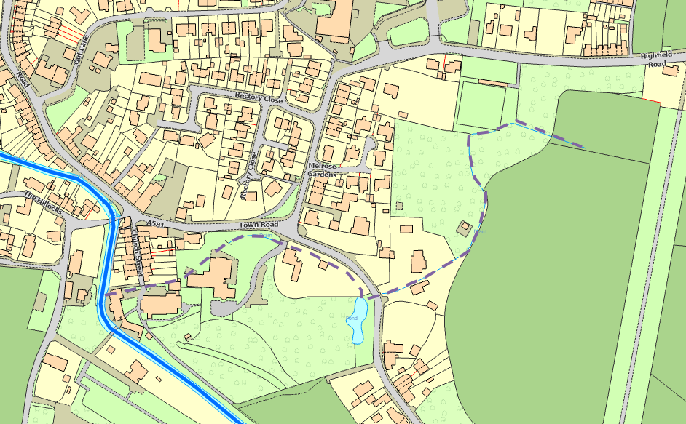

Qualitatively we can say that such measures would definitely reduce the pressure on the watercourse outfall to the river at the Old School House and would certainly contribute to reduced problems in the village roads, maybe even negate the need for a pump at all. We've done no work to quantify or cost these ideas, because as advised above, we don’t believe we can access funds for an appropriate technical assessment until we have clarity from the EA on the potential for more accommodating management of river levels.

I hope that helps for now? I'm happy to discuss further at any time. I've copied this message to Doug at Chorley BC who asked me a similar question recently.